Are HTML tags case sensitive?

Short and Sweet Answer : “NO”.

———————————————————————————————-

Now if i will not explain then it might be possible that my answer will be collapsed.

So, Follow below steps for example:

<html>

<body>

<h1>Hello , I think you will upvote my answer.</h1>

</body>

</html>

copy code in notepad and save as “first.html”

Open the file in your browser.

Now Copy below code :

<HTML>

<BODY>

<H1>Hello, I Think you will upvote my answer.</H1>

</BODY>

</HTML>

4. Save this code in notepad and save as “second.html”

5. Open the file in you browser.

Now, you can see both gives exactly same result.

Hence proved!!

1. Saving html file naming convention – index.html file is picked up by the browser automatically
2. HTML colors: can be specified in three ways – 1-colour name, 2-hexadecimal value (starts with ‘#’ and contains 6 letters [a-f] and [0-9]) 3- RGB code (e.g. rgb(0, 102,153)).
3. Anchor tag for site navigation: <a href =”page2.html”>Click here to go to Page 2</a>.
4. Target attribute with anchor tag,

target=”_blank” (whenever you click on the link a new tab opens up => no. of clicks = no. of new tabs) ,

target=”new” (when you first click on the link a new tab opens up => on second click same new tab will not open up)

1. Img tag: <img src=”image/pic.jpg” height=”150” width=”150”/> {no end tag required }.
2. Link styles:

<head>

<style>

a: link { color: pink; text-decoration: none // for removing under line }

a: visited {backgorund-color: yellow}

a: hover

a: active // rule: this order is necessary to be maintained

</style>

</head>

<body>

<a href=”page3.html” >Click here to navigate </a>

</body>

1. Comments tag: anything inside comment tag is not seen by the browser. /* .. */
2. Difference between head and body tag.
3. Meta tag:

<head>  
  <meta charset="UTF-8">  
  <meta name="description" content="Free Web tutorials"> // is visible when we search on google 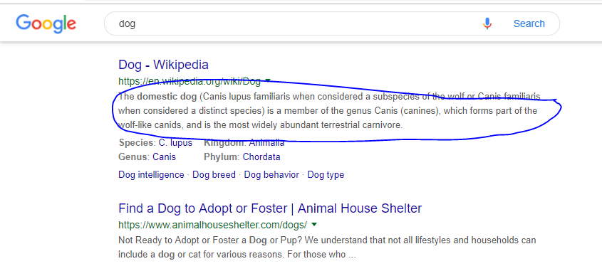  
  <meta name="keywords" content="HTML,CSS,XML,JavaScript">  
  <meta name="author" content="John Doe">  
  <meta name="viewport" content="width=device-width, initial-scale=1.0">

<meta http-equiv="refresh" content="30"> //**Refresh document every 30 seconds**  
</head>

1. Audio tag

<audio controls>

<source src="horse.ogg" type="audio/ogg">

<source src="horse.mp3" type="audio/mpeg">

Your browser does not support the audio element.

</audio>

1. Video tag

<video width="320" height="240" controls>

<source src="movie.mp4" type="video/mp4">

<source src="movie.ogg" type="video/ogg">

Your browser does not support the video tag.

</video>

1. Ordered list: 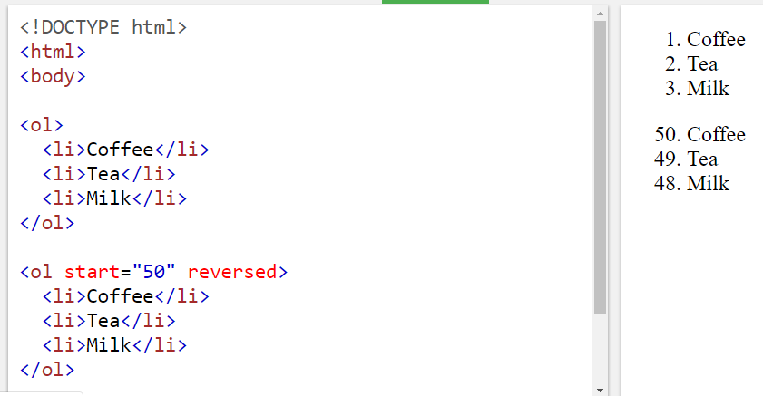

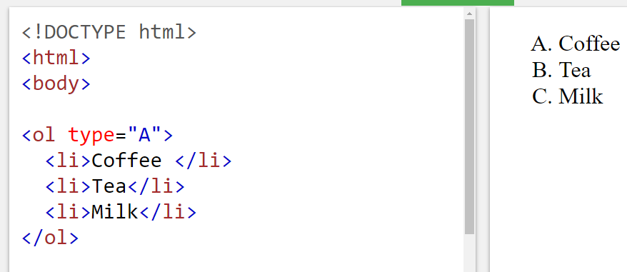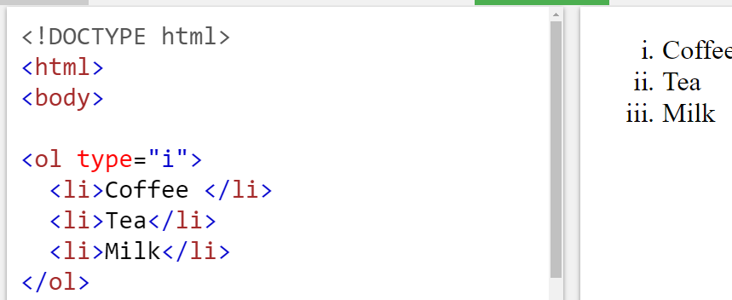

1. horizontal rule <hr> tag ,  tag has no end tag

CSS

1. All CSS syntax is case-insensitive within the ASCII range (i.e., [a-z] and [A-Z] are equivalent), except for parts that are not under the control of CSS.
2. Inline CSS - <h1 **style**="color:blue;"> - it is placed inside html tag
3. Internal CSS – In head section – inside <style> tags

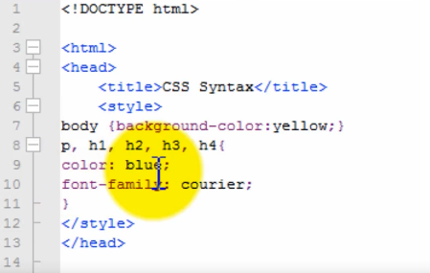

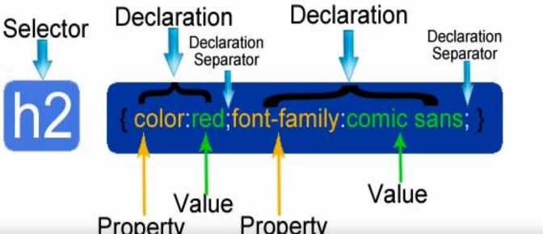

1. External CSS:

**<head>**

**<link** rel="stylesheet" type="text/css" href="mystyle.css"**>**

**</head>**

1. CSS Selector
   1. **Universal selector :** * { color: green; font-size: 10px }
   2. **ID selector :** <div id= “container” ></div> | #container { width: 90px; margin: 0 auto; }
   3. **Element type selector :** body { color: green; font-size: 10px }
   4. **Class selector:** declared with dot: <div class=”box”></div> | .box {padding : 20px; margin: 20px}
   5. **Descendent combinatory:** it is used to combine two or more selectors,

Html: <div id=”container”> <div class=”box”> </div> </div>

CSS: #container .box { float: left }

e.g. –HTML <p class=”fname”> </p>

CSS: p.fname { align: “center” } //for <p> tag and class =”fname”

1. Change Font size: three ways to set the size – pt (point), px (pixels), em (m)

 

e.g. – h1 { font-size: 18px }

1. A <span> element used to color a part of a text:

<p>My mother has <span style="color:blue">blue</span> eyes.</p>

1. Use the <mark> tag [defines marked text] if you want to highlight parts of your text.

e.g. <style>

mark {

background-color: red; /* default is yellow */

color: black;

}

</style>

</head>

<body><mark>Highlighted text!!</mark> </body>

Fonts:

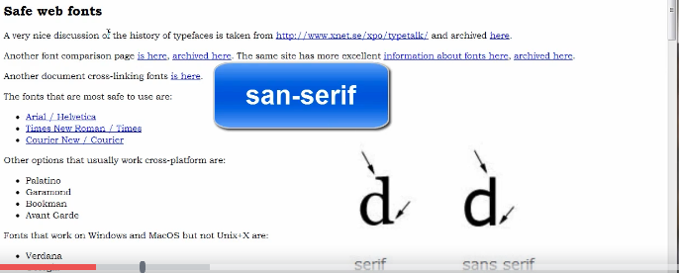

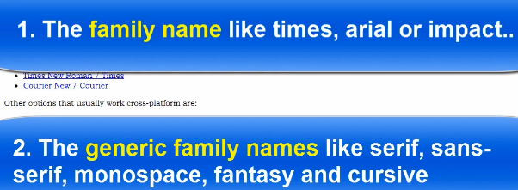

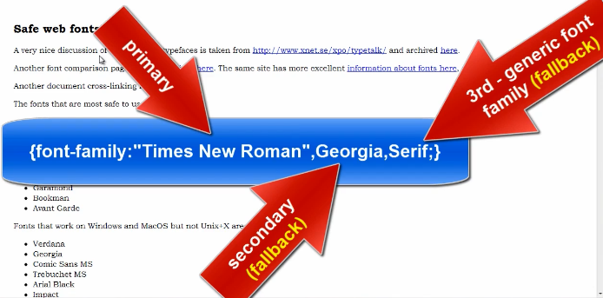

Fallback fonts are used when the primary font is not available on use computer.

Use “ “ when the font name contains more than one word,e.g. “Times New Roman”

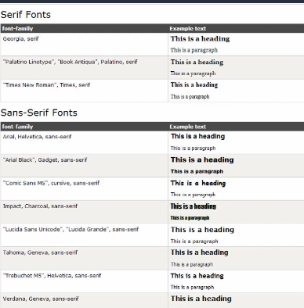

Font-styles

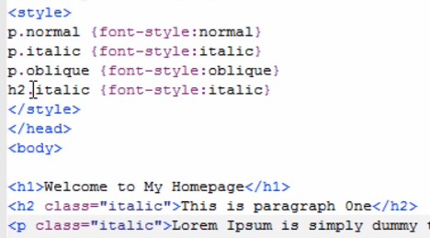

Add shadow effect

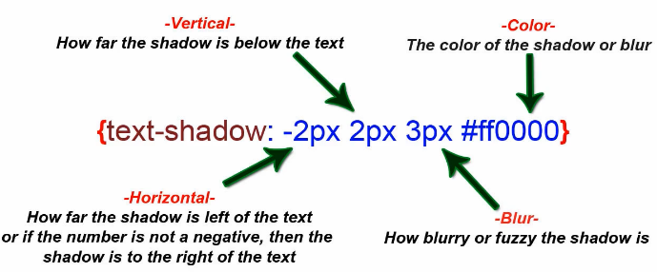

Content Box:

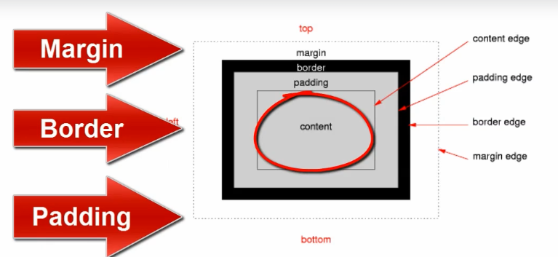

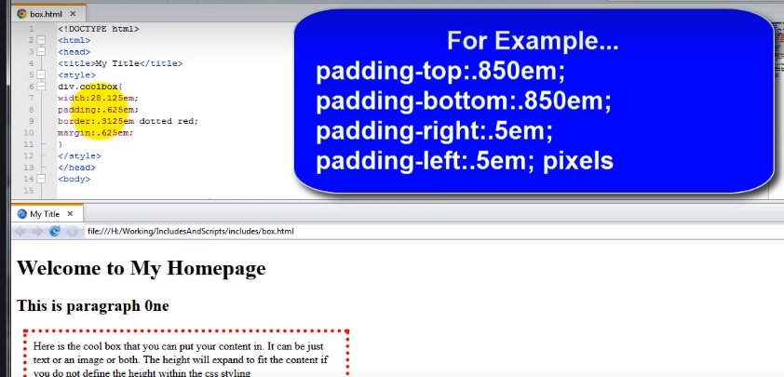

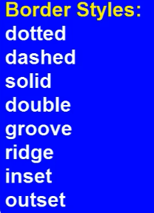

Rounded box:

